Daring Adult Wholesale Pty Ltd
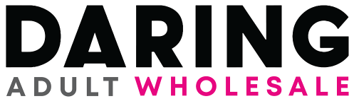
Distributor of Unique Premium Adult Products
ABN 34 638 159 261
ACN 638 159 261
Unit 5, 1 Business Dr Narangba Qld 4504
Phone: +61 7 3203 0344
Email: sales@daringadultwholesale.com.au

Faulty Product Form

*Please include any evidence of faults (images or video) attached in return email.

Product Details
Company Returning
Item Description
PROBLEM:

Outcome
Credit | Replacement to Retailer | Replacement to Customer

Replacement to Customer
Customer Name
Address

